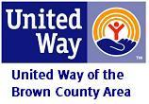
2025 Days of Caring

Project Registration Form
United Way of the Brown County Area Day of Caring
October 23-25, 2025

1) Name: ______________________________________ Phone #: _______________________
Address: ___________________________________________________________________________
Email: ____________________________________________________________________________
Contact name & Phone # (if different): ___________________________________________________
Are you a Veteran? Yes No

2) Please choose the date & project(s) you would like completed at your home:
c Thursday October 23rd, 2025 c Friday October 24th, 2025 c Saturday October 25th, 2025

Windows washed (outside only): Please give us the following details.
○ How many windows? ____________
○ Do you have a 2-story home? Yes No
○ Do you have a ladder volunteers can use? Yes No

- Yard work includes raking leaves, mowing your lawn, pruning bushes, weeding, or repotting plants.
Please explain:
___________________________________________________________________________________
Painting project (we can only accept small painting projects): Please explain:

___________________________________________________________________________________
- Other. Please explain in detail:

___________________________________________________________________________________

3) Materials you will provide to complete project:

4) Please further describe the details of your project:

_______________________________________________________________________

_______________________________________________________________________

*See next page—Signature Required.
6) Photo Consent
We would like your consent to photograph you and your property to use in promoting the Day of Caring. Please mark YES or NO below:

YES, United Way can take pictures of me for the Day of Caring – complete consent below:

I hereby authorize United Way of the Brown County Area to use any photo, any video and any other representational image taken of me on the Day of Caring for promotion including but not limited to inclusion in the annual report, on the website, in posters, brochures, videos and other materials.

Dated: (Signature)

NO Please do not photograph me.

7) Sign the consent below:

I, landowner/renter, hereby authorize and consent to allow volunteers participating in the Day of Caring Program to enter upon property rented/owned, for the purpose of clean up and restoration.

Dated: (Signature)

Please return this form online by October 17th,
if mailing the form please do so no later than October 10th, 2025.

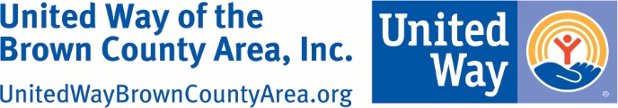

United Way of the Brown County Area, Inc.
PO Box 476 • New Ulm, MN 56073
Phone 507-354-6512
www.uwbrowncounty.org

